leqcia 9

3.6. bernulis*) gantoleba
gansazRvra 3.6.1.
(3.6.1)
gantolebas, sadac m nebismieri namdvili ricxvia, xolo da mocemuli funqciebia, bernulis gantoleba ewodeba.
roca $m=0,$ miviRebT Cven mier adre gamokvleul pirveli rigis wrfiv araerTgvarovan gantolebas, xolo roca $m=1,$miviRebT wrfiv gantolebas gancalebad cvladebSi. ufro zustad, marjvena mxareSi $y$ mamravlis frCxilebs gareT gatanis Semdeg, miviRebT pirvelis rigis wrfiv erTgvarovan gantolebas. amitom CavTvaloT, rom $m≠0,1\text{.}$maSinbernulis gantoleba arawrfivi gantoleba iqneba. advili dasamtkicebelia, rom is SeiZleba wrfiv gantolebaze daviyvanoT. SemoviRoT axali saZiebeli
(3.6.2)
funqcia, maSin
. (3.6.3)
axla, Tu (3.6.1)-is orive mxares gavamravlebT -ze, maSin (3.6.2)-isa da (3.6.3)-is gaTvaliswinebiT, gveqneba, rom
da
.
es ukanaskneli ki Cvens mier cxadi saxiT amoxsnil pirveli rigis wrfiv araerTgvarovan diferencialur gantolebas warmoadgens [ix. (3.1.11)].
SeniSvna 3.6.2. bernulis gantolebaze ufro zogad, roca ,
gantolebas rikatis*)gantoleba ewodeba. Tu $P(x)≡0,$ $Q(x)=a=\text{const},$ da $R(x)=b,$ $b=\text{const},$ cvladebi gancaldeba**), xolo Tu $R(x)={\text{bx}}^{−2},$ $b=\text{const},$ rikatis
gantolebis amonaxsni elementarul funqciebSi iwereba. marTlac, Tu SemoviRebT axal saZiebel funqcias (damokidebul cvlads)
tolobiT, rikatis gantoleba dava arawrfiv erTgvarovan gantolebaze [ix. (3.3.2)], radgan
da

3.6.1. balansis meTodi
davuSvaT, zedapiriT SemosazRvrul moculobaSi mimdinare raime procesi an movlena drois t momentSi aditiuri sididis mniSvnelobiT xasiaTdeba. G sididis aditiuroba Semdegnairad unda gavigoT: Tu moculobas gavyofT or nawilad da TiToeul nawilSi mimdinare igive procesi an movlena drois t momentSi xasiaTdeba da sidideebis mniSvnelobebiT, maSin . am sidides SeiZleba hqondes masis, energiis, impulsis, raime regionSi mosaxleobis raodenobis, sawarmoo fondebis da a. S. Sinaarsi. cxadia, rom Tu aRniSnavs raime regionSi mosaxleobis raodenobas, maSin warmoadgens am regionis Sesabamis zedapirs, xolo -s qveS am zedapiris SemomsazRvreli wiri igulisxmeba.
Cveni mizania, gavarkvioT, Tu ram SeiZleba gamoiwvios droTa ganmavlobaSi sididis cvlileba raime aTvlis sistemis mimarT fiqsirebul (ucvlel) moculobaSi da rogor SeiZleba am cvlilebis ricxviTi maxasiaTeblebis gamoTvla.
ganvixiloT konkretuli magaliTi. vTqvaT, raime dasaxlebuli punqtia, ki misi sazRvari. maSin am dasaxlebul punqtSi mosaxleobis raodenobis Secvlis ori ZiriTadi, erTmaneTisgan gansxvavebuli tipis mizezi arsebobs.
pirveli mizezia dasaxlebuli punqtidan mosaxleobis gamgzavreba anu misi sazRvris gadalaxva Signidan da dasaxlebul punqtSi mosaxleobis Camosvla, anu sazRvris gadalaxva garedan. sxva sityvebiT rom vTqvaT, dasaxlebul punqtSi mosaxleobis raodenobis cvlilebis erTi mizezia am punqtis SemomsazRvreli wiris gamWoli mosaxleobis `nakadebis~ arseboba.
mosaxleobis raodenobis cvlilebis meore mizezia dasaxlebul punqtSi adamianebis dabadeba da sikvdili. aqac, Tu sxva sityvebiT davaxasiaTebT am process, SeiZleba vTqvaT, rom -s SigniT mosaxleobis `wyaroebis~ moqmedebis Sedegad xdeba raodenobrivi cvlilebebi. “wyaroebis” cnebaSi vgulisxmobT sididis rogorc `gaCenas~, ise `gaqrobasac~. am `gaCenisa~ da `gaqrobis~ konkretuli mizezebi SeiZleba sxvadasxva iyos, magram am mizezebis detaluri ganxilva Cvens mizans ar warmoadgens.
amrigad, zedapiriT SemosazRvrul moculobaSi sididis cvlilebas ori saxis procesi ganapirobebs: zedapiris gamWoli sididis `nakadi~ da TviT moculobaSi sididis `wyaroebis~ moqmedeba.
rogorc aRvniSneT, sazogadod, SesaZlebelia arsebobdes rogorc `nakadebis~, aseve `wyaroebis~ sxvadasxva saxeoba. kerZod, zemoT ganxilul magaliTSi mosaxleobis raodenobis cvlilebis Sesaxeb rogorc `nakadis~, aseve `wyaroebis~ or-ori saxeoba gvqonda: `gasvla~ da `Semosvla~, `dabadeba~ da `sikvdili~. am SemTxvevaSi maTematikuri modelis Sedgenisas gaTvaliswinebul unda iqnes rogorc nakadebis, aseve wyaroebis yvela saxeobis erToblivi moqmedebis Sedegebi.
gadavideT axla raodenobrivi Tanafardobebis dadgenaze.
Tu vigulisxmebT, rom funqcia uwyveti da warmoebadia, maSin warmoebuli moculobaSi G sididis cvlilebis siCqares, anu moculobaSi drois erTeulSi G sididis cvlilebas warmoadgens.
sididis im raodenobas, romelic nakadebis yvela saxeobis erToblivi moqmedebis Sedegad gamWoli moZraobiT gaivlis zedapirs drois erTeulSi, vuwodoT`G sididis nakadi~ da aRvniSnoT igi Q simboloTi, xolo G sididis im raodenobas, romelic wyaroebis yvela saxeobis erToblivi moqmedebis Sedegad Cndeba moculobaSi drois erTeulSi, vuwodoT `G sididis wyaroebis simZlavre~ da aRvniSnoT igi F-iT.
axla ukve sirTules aRar warmoadgens, SevadginoT `balansi~*) _ moculobaSi G sididis Semcvelobis cvlileba drois erTeulSi gavutoloT G sididis nakadisa da wyaroebis simZlavris jams:
. (3.6.4)
am gantolebas balansis gantolebas vuwodebT. swored is warmoadgens balansis meTodis maTematikur formulirebas.
ganvixiloT ekologiis zogierTi maTematikuri modeli, romelSic diferencialuri gantolebebi iqneba gamoyenebuli. am SemTxvevaSi drois cvlileba uwyvetad xdeba da maTematikuri modelis saSualebiT drois nebismier momentSi ama Tu im populaciis Sesaxeb daskvnis gakeTebis saSualeba gveqneba. SevniSnoT, rom maTematikuri modelebis agebisas Cven mier zemoT aRwerili balansis meTodi iqneba gamoyenebuli.

3.6.2. populaciis malTusis diferencialuri modeli
malTusis models safuZvlad udevs martivi debuleba _ populaciaSi individebis raodenobis cvlilebis siCqare t momentSi individebis $N(t)$ raodenobis pirdapirproporciulia.
vTqvaT, $N(t)$ raime populaciaSi individebis raodenobas warmoadgens t momentSi. Tu A im individebis raodenobaa, romlebic drois erTeulSi ibadebian, xolo B _ im individebis raodenoba, romlebic drois erTeulSi kvdebian, maSin balansis meTodis gaTvaliswinebiT SegviZlia davaskvnaT, rom arsebobs sakmaod seriozuli safuZveli imisTvis, raTa $N(t)$ sididis cvlilebis siCqare ganvsazRvroT Semdegi diferencialuri gantolebis saSualebiT
$\frac{\text{dN}}{\text{dt}}=A−B,$ (3.6.5)
sadac $A=αN,$$B=βN,$ xolo $α=α(t,N),$ $β=β(t,N),$ Sesabamisad dabadebisa da sikvdilianobis koeficientebia, romlebic cdiT – statistikur monacemTa gasaSualebiT dgindeba. amdenad, (3.6.5) gantoleba SeiZleba ase gadaiweros:
. (3.6.6)
Tu , , e.i. Tu da koeficientebi mxolod t drois cvladzea damokidebuli, maSin, (3.1.10) formulis Tanaxmad, (3.6.6) gantolebis amonaxsns aqvs
(3.6.7)
saxe, sadac populaciaSi individebis raodenobaa sawyis momentSi.
naxazze (ix. nax. 3.6.1) mocemulia funqciis grafikebi, rodesac , , sadac da mudmivebia (erTmaneTis msgavs mrudeebs sawyisi momentis sxvadasxva mniSvneloba Seesabameba). am SemTxvevaSi, (3.6.7)-dan integrebiT gamomdinareobs, rom (3.6.6) gantolebis amonaxsns
funqcia warmoadgens.
Tu , maSin populaciaSi individebis raodenoba mudmivia, e.i. sawyisi mniSvnelobis tolia.
Tu , maSin eqsponencialurad, rodesac .
Tu , maSin aseve eqsponencialurad, rodesac .
am garemoebam malTuss saSualeba misca, gamoeTqva eWvi imis Sesaxeb, rom dedamiwaze mosaxleobis mkveTri zrda moxdeba misgan gamomdinare yvela SedegiT.

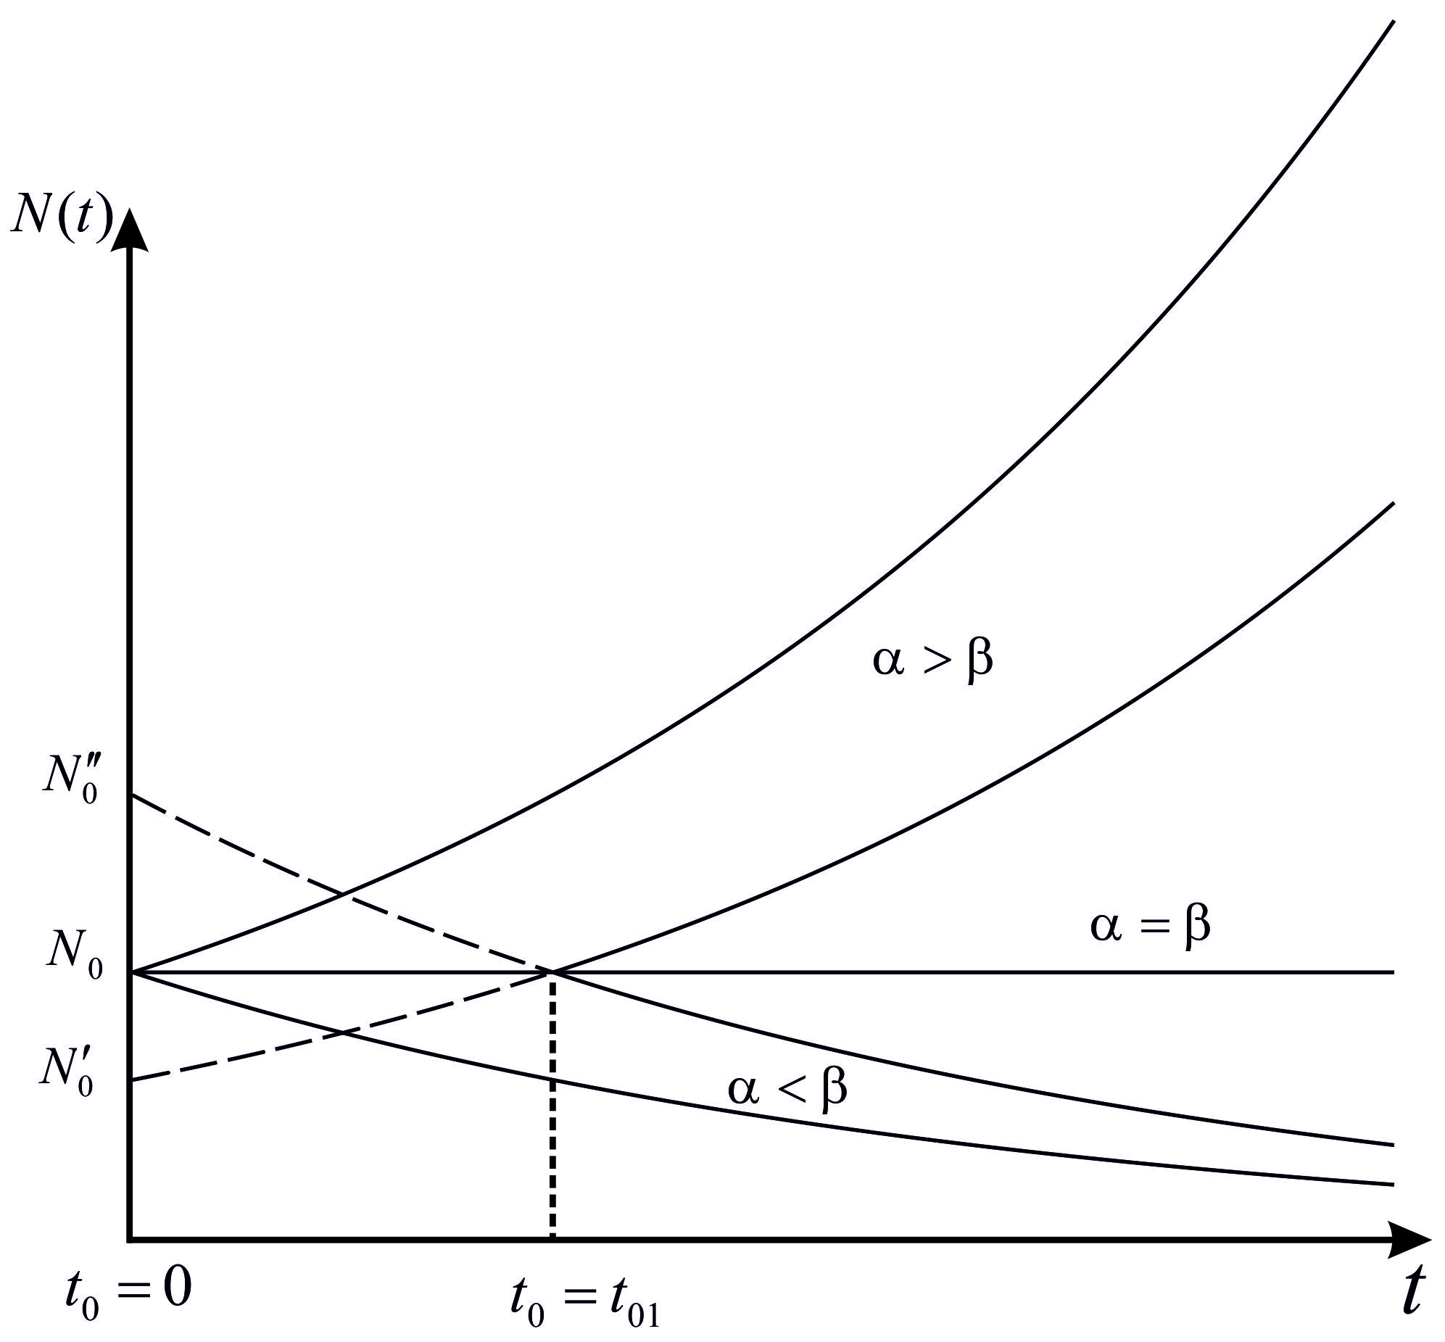
nax. 3.6.1

Tumca moyvanili maTematikuri modeli uaRresi gamartivebis gamo ararealisturia, miuxedavad amisa, is kargad aRwers baqteriebis koloniebSi individTa raodenobis zrdis dinamikas sakvebi garemos gamofitvamde. amrigad, Cven mier ganxiluli maTematikuri modeli samarTliania garkveul pirobebSi _ drois mcire monakveTSi. am daskvnas zogierTi tipis baqteriebze Catarebuli realuri eqsperimentebis Sedegebi adasturebs.
amasTan dakavSirebiT moviyvanoT maTematikuri modelis erTi saintereso magaliTi. mkvlevarebis mizani iyo, SeeswavlaT dedamiwaze mosaxleobis raodenobis zrdis dinamika.
vTqvaT, mosaxleobis zrdis siCqare mamakacebisa da qalebis raodenobis namravlis proporciulia (es hipoTezaa, romelic bevr praqtikulad saintereso SemTxvevaSi dasturdeba), e.i. dedamiwaze mosaxleobis raodenobis zrdis dinamika aRvweroT Semdegi diferencialuri gantolebiT:
, (3.6.8)
sadac dedamiwaze mosaxleobis raodenobaa drois t momentSi, da _ Sesabamisad mamakacebisa da qalebis raodenoba, _ proporciulobis garkveuli koeficienti.
sakmarisad didi sizustiT SeiZleba CavTvaloT, rom
,
maSin (3.6.8) miiRebs rikatis (ix. SeniSvna 3.6.2)
(3.6.9)
gantolebis saxes.
vTqvaT, momentSi mosaxleobis raodenobaa , maSin (3.6.9) gantolebis amonaxsni am sawyisi monacemiT gamoisaxeba Semdegi formulis saSualebiT:
, (3.6.10)
sadac
.
marTlac, SemoviRoT
(3.6.11)
aRniSvna. maSin, radganac
,
(3.6.9) gantoleba Semdegi saxiT Caiwereba:
,
saidanac -dan t-mde integrebiT miviRebT, rom
an rac igivea
da
,
aqedan
e. i. (3.6.11)-is gaTvaliswinebiT,
amrigad, momentSi dedamiwaze mcxovrebTa raodenoba usasrulo gaxdeba. `samyaros aRsasrulis~ droa. dedamiwis mosaxleobis statistikuri monacemebis gaTvaliswinebiT gamoTvales koeficientis mniSvneloba da daadgines, rom katastrofa moxdeba paraskevs, 2026 wlis 13 noembers. magram katastrofa ar moxdeba, radgan ufro zusti meTodebiT dadgenilia, rom am droisTvis dedamiwis mosaxleoba 10 miliards miaRwevs da ara -s.
rogorc aRvniSneT, (3.6.6) gantoleba kargad aRwers zogierT populaciaSi individTa raodenobis zrdis dinamikas drois mcire monakveTSi. amis Semdeg am procesze gavlenas axdens sakvebi resursebis nakleboba, rac maTematikur models SesamCnevad cvlis. am SemTxvevaSi SeiZleba populaciaSi garkveul doneze individTa raodenobis stabilizacia moxdes, an es raodenoba SeiZleba regularul an araregularul fluqtuaciebs ganicdides, an es raodenoba SeiZleba Semcirdes.
iseTi populaciis yofaqceva, romelSic individTa raodenoba garkveul mdgrad doneze stabilizirdeba, xSirad aRiwereba Semdegi lojistikuri gantolebis saSualebiT:
, (3.6.12)
sadac $x=x(t)$ populaciaSi individTa raodenobaa t momentSi, xolo $a>0,$ $b>0$ garkveuli cdiseuli mudmivebi. (3.6.12) gantoleba bernulis (3.6.1) gantolebisa da rikatis (ix. SeniSvna 3.6.2) gantolebis kerZo SemTxvevaa.
(3.6.12) gantoleba warmoadgens umartives diferencialur gantolebas, romelsac Semdegi ori mniSvnelovani Tviseba gaaCnia:
1) x-s mcire mniSvnelobebisTvis (3.6.12) gantolebis amonaxsni uaxlovdeba (3.6.6) gantolebis, roca da mudmivebia, amonaxsns da aqvs eqsponencialuri xasiaTi.
2) t-s zrdasTan erTad monotonurad uaxlovdeba garkveul mudmiv mniSvnelobas, rac populaciaSi individTa raodenobis stabilizacias asaxavs.
ganvixiloT koSis amocana (3.6.12) gantolebisTvis
, (3.6.13)
sadac populaciaSi individTa raodenobaa momentSi, romelic dadebiTia.
advilad SeiZleba SevamowmoT, rom (3.6.12), (3.6.13) amocanis amonaxsns aqvs Semdegi saxe:
. (3.6.14)
aqedan Cans, rom, rodesac , maSin populaciaSi individTa raodenoba . amasTan SesaZlebelia ori SemTxveva: da . gansxvaveba am or SemTxvevas Soris kargad Cans nax. 3.6.2-ze (aq ganxilulia SemTxveva, rodesac ).

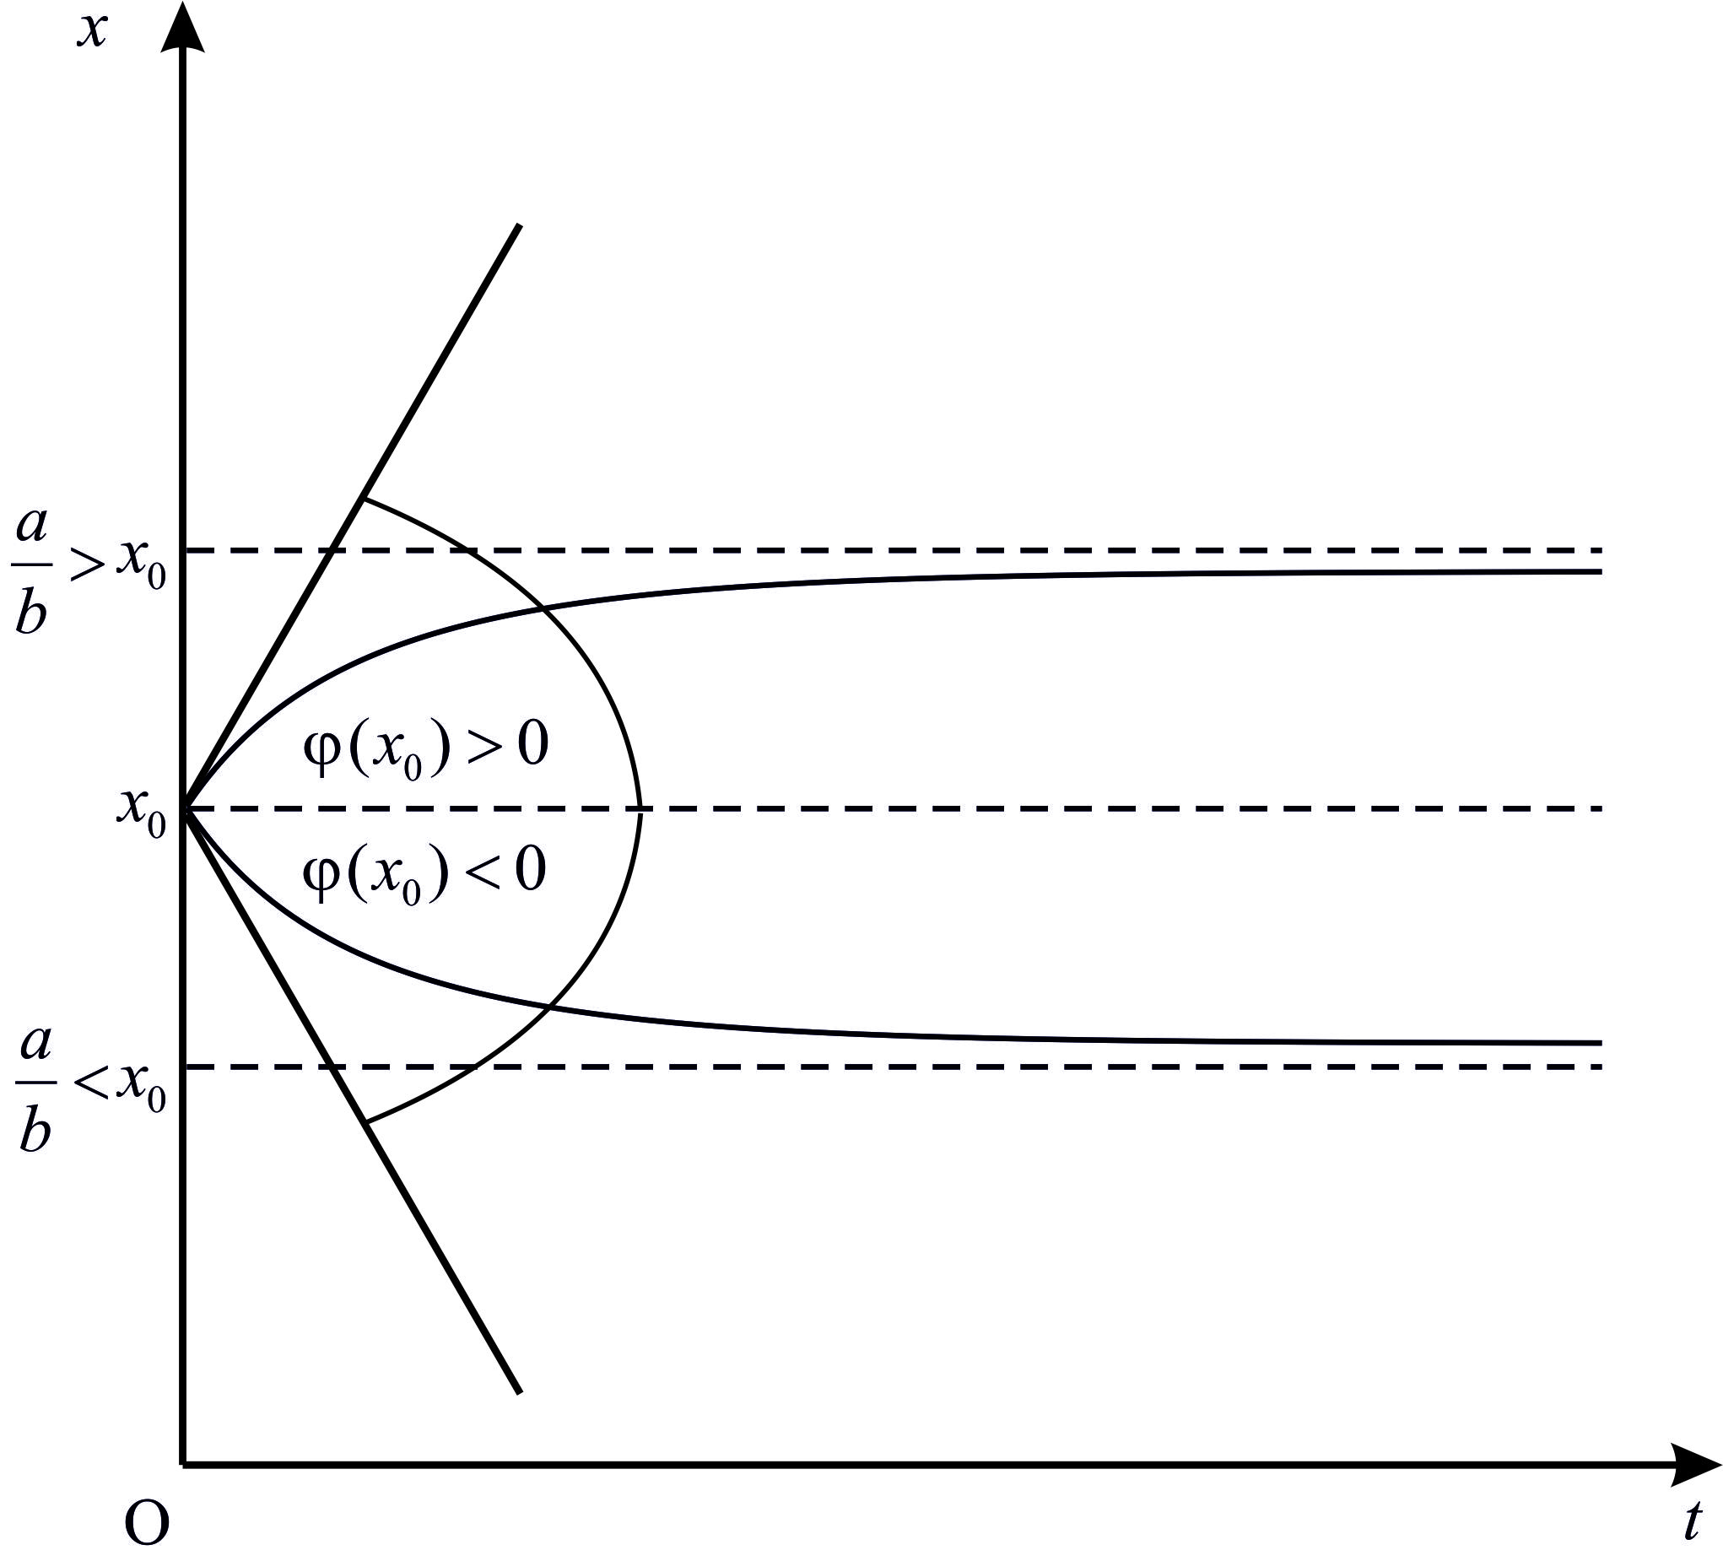
nax. 3.6.2

SevniSnoT, rom (3.6.12) gantoleba da, maSasadame, (3.6.14) funqcia sakmaod kargad aRwers zogierTi tipis baqteriis populaciaSi individebis raodenobis cvlis dinamikas sawyis etapze (mag., kulturaSi safuaris ujredebis cvlilebis dinamikas).
amovxsnaT koSis (3.6.12), (3.6.13) amocana. SemoviRoT aRniSvna. maSin
da (3.6.12) gantoleba SeiZleba CavweroT
saxiT. aqedan
am ukanasknelis zogad amonaxsns, (3.1.13)-is Tanaxmad, aqvs Semdegi saxe
amitom
saidanac, (3.6.13) sawyisi pirobis gaTvaliswinebiT,
e.i.,
amrigad,
da miviReT (3.6.14).
cxadia,
$$x'(t)=−\frac{\frac{a}{b}x_{0}\left(\frac{a}{b}−x_{0}\right)e^{−a(t−t_{0})}⋅(−a)}{\left[x_{0}+\left(\frac{a}{b}−x_{0}\right)e^{−a(t−t_{0})}\right]}, x'(t_{0})=\frac{\frac{a}{b}x_{0}\left(\frac{a}{b}−x_{0}\right)}{\frac{a^{2}}{b^{2}}}={\text{bx}}_{0}\left(\frac{a}{b}−x_{0}\right)=\text{tg}ϕ(x_{0})≠0\text{.}$$

3.6.3. epidemiologiis umartivesi maTematikuri modelebi
jer gavixsenoT modelTan dakavSirebuli zogierTi cneba.
baqteriebi − umetesad erTujrediani organizmebis jgufi. ganekuTvneba „atomamdel“ − birTvamde molekulur formebs − prokariotebs. sferuli (kokebi), Reroseburi (bacilebi), Zafiseburi dagrexili (vibrionebi), spiraliseburi; ikvebebian sxvadasxva organuli nivTierebebiT an qmnian araorganulidan organul erTujredian nivTierebebs.
virusebi − mcire zomis araujredovani nawilakebi, romlebic Sedgeba nukleinuri (maRalmolekuluri organuli naerTebi Sedgeba azoturi safuZvlis, naxSirbadis da fosforuli mJaveebis narCenebisgan) mJavisagan da cilovani (cilebi − maRalmolekuluri organuli nivTierebebi Sedgeba 20 tipis aminomJavisgan da warmoadgenen organizmebis sicocxlisunarianobis procesebis safuZvels) garsisagan. forma Reroseburia (Cxiriseburi) 10 dan-3000 nanometramde da ufro didebic; ujredSiga parazitebia. iyeneben maT fermertul aparats da gardaqmnian momwifebuli virusebis sinTezad. iwveven daavadebebs.
istoriidan cnobilia faqtebi, rodesac sxvadasxva epidemiuri daavadebisgan (qolera, Savi Wiri, gripi da sxva) mravali adamiani iRupeboda. imisTvis, rom efeqturad vebrZoloT am daavadebaTa gavrcelebas, saWiroa, winaswar ganisazRvros, Tu ra Sedegi mohyveba daavadebis sawinaaRmdego RonisZiebebs, e.i. saWiroa moxdes sxvadasxva RonisZiebis Catarebis Sedegad avadmyofTa raodenobis dinamikis prognozireba. aqedan gamomdinare, mivdivarT iseTi maTematikuri modelis Seqmnis aucileblobamde, romelic daavadebis gavrcelebis garkveuli prognozirebis saSualebas iZleva.
simartivisTvis jer ganvixiloT situacia, rodesac araferi keTdeba ama Tu im epidemiis gavrcelebis winaaRmdeg, e.i. movaxdinoT epidemiis gavrcelebis bunebrivi procesis prognozireba.
cxadia, maTematikuri modeli epidemiis gavrcelebaze sxvadasxva faqtoris gavlenas unda iTvaliswinebdes. magaliTad, gaTvaliswinebuli unda iyos is kanonebi, romelTa mixedviTac xdeba ama Tu im virusis gamravleba, calkeuli adamianis imuniteti ama Tu im daavadebis mimarT, infeqciis matarebeli adamianebis Sexvedris albaToba janmrTel adamianebTan da mravali sxva faqtori. sxva sityvebiT rom vTqvaT, epidemiis ase Tu ise sruli modeli unda Seicavdes im kvlevis Sedegebs, romelsac mecnierebis sul cota oTxi dargi mainc awarmoebs, kerZod, mikrobiologia, medicina, farmakologia da socialuri fsiqologia.
radgan Cveni mizani mxolod sailustrcio modelis Sedgenaa, amitom maTematikuri modelis Sedgenisas bevr faqtors ar gaviTvaliswinebT. amis miuxedavad, aseTi uxeSi modelis saSualebiTac ki SeiZleba epidemiis gavrcelebis meqanizmis aRwera mis garkveul etapze.
amrigad, ganvixiloT adamianebis jgufi, romelic individisgan Sedgeba. vTqvaT, momentSi am jgufSi moxvda avadmyofi $N_{0}$ adamiani (infeqciis wyaro). vigulisxmoT, rom am jgufisgan arc erTi avadmyofis CamoSoreba (mag., karantinis saSualebiT) ar xdeba, aseve ar aris arc gamojanmrTelebisa da arc sikvdilis SemTxvevebi. aseTi daSvebebi sruliad bunebrivia epidemiis dawyebidan drois mcire intervalis ganmavlobaSi. CavTvaloT agreTve, rom nebismieri adamiani infeqciis wyarod iTvleba maSinve, rodesac is daavaddeba.
aRvniSnoT t momentSi daavadebuli adamianebis raodenoba simboloTi, xolo jerjerobiT janmrTeli adamianebis raodenoba _ simboloTi. cxadia, Cveni daSvebebis pirobebSi t-s nebismieri mniSvnelobisTvis samarTliania
(3.6.15)
toloba. rodesac , maSin $x(0)=N_{0}$.
cxadia, daavadebuli adamianebis raodenobis cvlilebis siCqare damokidebulia avadmyofi da janmrTeli adamianebis Sexvedraze, e.i. SeiZleba CavTvaloT, rom es siCqare namravlis proporciulia. am daSvebis safuZvelze SegviZlia davweroT
an, Tu (3.6.15) tolobas gaviTvaliswinebT, bernulis*)
(3.6.16)
gantoleba, sadac garkveuli mudmivia. miRebuli diferencialuri gantolebisTvis ganvixiloT koSis amocana
$x(0)=N_{0}$ (3.6.17)
sawyisi pirobiT.
(3.6.16), (3.6.17) warmoadgens epidemiis gavrcelebis umartives models, romlis saSualebiTac drois nebismier t momentSi daavadebuli adamianebis raodenobis gansazRvra SeiZleba.
amovxsnaT es amocana. am mizniT SemoviRoT
aRniSvna, saidanac miviRebT, rom
$$\frac{\text{dU}}{\text{dt}}=−\frac{1}{x^{2}(t)}\frac{\text{dx}}{\text{dt}}=−\frac{1}{x^{2}(t)}αx(t)\left[N−x(t)\right]=−\frac{αN}{x(t)}+α=−α\text{NU}(t)+α\text{.}$$
Tu am ukanasknel tolobas gaviTvaliswinebT, (3.6.16) gantoleba SeiZleba Semdegi saxiT CavweroT:
, (3.6.18)
radgan $x(0)=N_{0}$, amitom $U(0)=\frac{1}{N_{0}}$.
advilad SeiZleba davamtkicoT, rom $U(0)=\frac{1}{N_{0}}$ sawyisi pirobebis gaTvaliswinebiT (3.6.18) gantolebis amonaxsns warmoadgens Semdegi funqcia:
,
saidanac miviRebT, rom
$x(t)=\frac{{\text{NN}}_{0}}{N_{0}+(N−N_{0})e^{−αN t}}$. (3.6.19)
marTlac, Tu gamoviyenebT (3.1.13) formulas, gveqneba, rom
.
aq CavsvaT da davakmayofiloT sawyisi piroba, maSin
$U(0)=c=\frac{1}{N_{0}}$.
amrigad,
$U(t)=e^{−α\text{Nt}}\left(\frac{1}{N_{0}}+\frac{e^{α\text{Nt}}}{N}−\frac{1}{N}\right)=\frac{1−e^{−α\text{Nt}}}{N}+\frac{e^{−α\text{Nt}}}{N_{0}}=\frac{\left(1−e^{−α\text{Nt}}\right)N_{0}+{\text{Ne}}^{−α\text{Nt}}}{{\text{NN}}_{0}}$.
saidanac, radgan
,
gamomdinareobs (3.6.19).
gavaanalizoT miRebuli formula. t-s zrdasTan erTad wiladis mniSvneli mcirdeba, e.i. izrdeba. es Seesabameba Cvens varauds, rom avadmyofTa raodenoba SeiZleba mxolod gaizardos. cxadia, $\underset{t→∞}{\text{lim}}x(t)=N$, e.i. yvela daavaddeba.
sainteresoa, gamovikvlioT, Tu rogor icvleba daavadebuli adamianebis raodenobis zrdis siCqare. am sakiTxis Sesaswavlad unda gamovikvlioT sidide.
(3.6.19)-is orjer gawarmoebiT miviRebT, rom
$$\begin{aligned}\frac{d^{2}x}{{\text{dt}}^{2}}=\frac{d}{\text{dt}}\left(\frac{d x}{\text{dt}}\right)=\frac{d}{\text{dt}}\frac{{αN}^{2}N_{0}(N−N_{0})e^{−α\text{Nt}}}{{\left[N_{0}+(N−N_{0})e^{−α\text{Nt}}\right]}^{2}} \\ \frac{−{αN}^{3}N_{0}(N−N_{0})e^{−α\text{Nt}}{\left[(N−N_{0})e^{−α\text{Nt}}+N_{0}\right]}^{2}+2α^{2}N^{3}N_{0}e^{−2α\text{Nt}}\left[(N−N_{0})e^{−α\text{Nt}}+N_{0}\right]}{{\left[N_{0}+(N−N_{0})e^{−α\text{Nt}}\right]}^{4}} \\ \frac{α^{2}N^{3}N_{0}(N−N_{0})\left[(N−N_{0})e^{−2α\text{Nt}}−N_{0}e^{−α\text{Nt}}\right]}{{\left[N_{0}+(N−N_{0})e^{−α\text{Nt}}\right]}^{3}}\text{.}\end{aligned}$$
aqedan gamomdinareobs, rom $\frac{d^{2}x}{{\text{dt}}^{2}}=0 ,$ rodesac $t=\frac{\text{ln}\frac{N−N_{0}}{N_{0}}}{αN} ,$ marTlac mricxvelSi kvadratul frCxilebSi moTavsebulis nulTan tolobidan ($e^{−α\text{Nt}}−$ze Sekvecis Semdeg) gveqneba, rom $(N−N_{0})e^{−α\text{Nt}}=N_{0}$ aqedan $\frac{(N−N_{0})}{N_{0}}e^{−α\text{Nt}}=1,$ bolo tolobis galogariTmebis Semdeg miviRebT $\text{ln}\frac{(N−N_{0})}{N_{0}}−α\text{Nt}=0,$ amrigad, $t=\frac{\text{ln}\frac{(N−N_{0})}{N_{0}}}{αN}\text{.}$
kerZod, Tu $N_{0}=1,$
rodesac*) $t=\frac{\text{ln} (N−1)}{αN} ;$
Tu , maSin ;
Tu , maSin .
amrigad, funqcia, romelic avadmyofTa raodenobis zrdis siCqares gamoxatavs, momentamde izrdeba, xolo Semdeg iklebs. es Sedegi, uxeSi maTematikuri modelis miuxedavad, sakmaod kargad eTanxmeba eqsperimentul monacemebs, gansakuTrebiT epidemiis sawyis etapze.
eqsperimenti kompiuterze. epidemiis gavrcelebis analizi saqarTveloSi, TbilisSi da regionebSi.
jer lokaciisTvis davadginoT tempi (rate) $n$ dRisTvis (magaliTad 7 dRisTvis).
kvlevis dawyebis dRes Sesabamis lokaciaze (adgilze) daavadebulTa raodenoba miviRoT sawyis $N_{0}$ mniSvnelobad. momdevno pirvel ($t_{1}=1$) dRes daavadebulTa raodenoba imave lokaciaze avRniSnoT $N_{1}$-iT. es mniSvneloba CavsvaT (3.6.19)-is marcxena mxareSi da vipovoT $α$-s mimarT gantolebis $α_{1}$amonaxsni (magaliTad, Maple-is an MatLab-is gamoyenebiT). meore ($t_{2}=2$) dRes daavadebulTa raodenoba aRvniSnoT$N_{2}$-iT. es mniSvneloba CavsvaT (3.6.19)-is marcxena mxareSi, xolo $N_{1}$-is mniSvneloba CavsvaT $N_{0}$-is nacvlad (3.6.19)-is marjvena mxareSi $α$-s mimarT miRebuli gantolebis amoxsniT miviRebT $α_{2}$-s mniSvenelobas da a.S.
$$N_{n}≡x(t_{n})=\frac{{\text{NN}}_{n−1}}{N_{n−1}+(N−N_{n−1})e^{−α_{n} {\text{Nt}}_{n}}}\text{.}$$
gantolebis $α_{n}$-is mimarT amoxsnis Semdeg miviRebT $α_{1}$, $α_{2},\text{.}\text{.}\text{.},$$α_{n}$ mimdevrobas. gamovTvaloT saSualo ariTmetikuli
$$α=\frac{α_{1}+α_{2}+\text{.}\text{.}\text{.}+α_{n}}{n}\text{.}$$
amis Semdeg $α$-s miRebuli mniSvnelobis, sawyis $N_{0}$ mnivnelobasTan erTad, (3.6.19)-is marjvena mxareSi CasmiT, (3.6.19)-is e.i.
$$N_{n}^{p}=\frac{{\text{NN}}_{0}}{N_{0}+(N−N_{0})e^{−α {\text{Nt}}_{n}}}$$
gamoTvlis Semdeg miviRebT $n$-uri dRis prognozs.
axla ganvixiloT epidemiis sxva maTematikuri modeli, romelSic zogierTi iseTi faqtoris gaTvaliswineba xdeba, romelsac epidemiis Cven mier ganxiluli umartivesi (da rogorc aRvniSneT, uxeSi) modeli ar iTvaliswinebda.
davuSvaT, rom raime populacia, romelic N individisgan Sedgeba, sam jgufad iyofa. pirvel jgufs mivakuTvnoT individebi, romlebic mocemul momentSi janmrTelebi arian, magram ar aqvT imuniteti garkveuli daavadebis mimarT, e.i. arsebobs imis garkveuli albaToba, rom isini daavaddebian. aseTi individebis raodenoba t momentSi aRvniSnoT simboloTi. meore jgufs mivakuTvnoT individebi, romlebic aRebul momentSi avad arian da, maSasadame, infeqciis gamavrceleblad iTvlebian. maTi raodenoba t momentSi aRvniSnoT simboloTi. dabolos, mesame jgufs mivakuTvnoT individebi, romlebic ar arian avad da amave dros aqvT imuniteti am daavadebis mimarT. maTi raodenoba aRvniSnoT simboloTi. e. i.
. (3.6.20)
davuSvaT, rom im SemTxvevaSi, rodesac daavadebulTa ricxvi garkveul fiqsirebul ricxvs gadaaWarbebs, e.i. , iwyeba epidemiis procesi, e.i. maT SeuZliaT daaavadon is individebi, romelTac am daavadebis mimarT imuniteti ar aqvT. es ki imas niSnavs, rom garkveul momentamde SesaZlebelia daaavadebul individTa izolacia (mag., karantinis saSualebiT) da rom sawyis etapze daavadeba garkveuli, mcirericxovani jgufis SigniT mimdinareobs. daavadebis am etaps maTematikur modelSi ar aRvwerT.
CavTvaloT, rom da imunitetis armqone janmrTeli individebis jgufSi daavadebis gamo individTa raodenobis cvlilebis siCqare am jgufSi myofi individebis raodenobis proporciulia. am daSvebebis Sedegad miviRebT
(3.6.21)
diferencialur gantolebas.
davuSvaT, rom im individTa raodenobis cvlilebis siCqare, romlebic daavadebulTa jgufs miekuTvnebian, magram gamojanmrTeldnen, proporciulia am jgufSi individebis raodenobisa da -s tolia. Tu gaviTvaliswinebT agreTve, rom imunitetis armqone individi bolos da bolos avaddeba da TviTon xdeba infeqciis gamavrcelebeli (e. i. aseTi individi meore jgufSi gadadis), amitom infeqciis gamavrcelebelTa raodenobis cvlilebis siCqare damokidebulia drois erTeulSi daavadebul da gamojanmrTelebul individTa raodenobis sxvaobaze. amrigad,
(3.6.22)
(3.6.21) da (3.6.22) gantolebebSi proporciulobis da koeficientebs Sesabamisad vuwodoT daavadebisa da gamojanmrTelebis koeficientebi.
dabolos, Tu CavTvliT, rom gamojanmrTelebuli individebi imunitets iZenen, maSin janmrTeli individebis (romlebsac am daavadebis mimarT imuniteti gaaCniaT) raodenobis cvlileba SeiZleba Semdegi gantolebiT aRvweroT:
. (3.6.23)
miviReT (3.6.21)-(3.6.23) diferencialur gantolebaTa sistema (ix. $3.7). ganvixiloT koSis amocana am gantolebaTa sistemisTvis (TiToeul jgufSi individTa raodenoba sawyis momentSi):
, , . (3.6.24)
(3.6.21)-(3.6.24) amocana epidemiis gavrcelebis maTematikur models warmoadgens garkveul SezRudvebSi, romelTa Sesaxebac zemoT gvqonda laparaki. cxadia, rom am gantolebebidan SegviZlia nebismieri SevcvaloT (3.6.20) gantolebiT. kerZod, Tu amovxsniT (3.6.21) da (3.6.22) gantolebebs, SegviZlia miviRoT (3.6.20)-dan.
msjelobis simartivisTvis davuSvaT, rom sawyis etapze aRebul populaciaSi ar arian individebi, romlebsac garkveuli daavadebis mimarT imuniteti aqvT, e.i. $R_{0}=0\text{.}$ am daSvebis Sedegad imunitets is individebi iZenen, romlebic avadmyofobis Semdeg gamojanmrTeldebian. aseve davuSvaT, rom daavadebisa da gamojanmrTelebis koeficientebi erTmaneTis tolia: (SevniSnoT, rom Tu , es msjelobaSi raime garTulebas ar gamoiwvevs).
ganvixiloT ori SemTxveva:
I. vTqvaT, . Cveni daSvebis Tanaxmad am dros populaciaSi Semaval individebs daavadeba ar gadaecemaT. am SemTxvevaSi
,
ris safuZvelzec (3.6.20) tolobis da
pirobis gaTvaliswinebiT miviRebT:
.
es modeli im situacias aRwers, rodesac yvela daavadebuli individi gamojanmrTelebulia. am SemTxvevaSi (3.6.22) miiRebs
saxes, saidanac, cvladTa gancalebiT da (3.6.24) sawyisi pirobis gaTvaliswinebiT, miviRebT, rom
,
.
nax. 3.6.3-ze grafikulad aris gamoxatuli individebis raodenobis cvlileba samive jgufSi.
II. vTqvaT, . am SemTxvevaSi iarsebebs intervali, sadac Sesrulebuli iqneba utoloba. aqedan gamomdinareobs, rom Tu , maSin avadmyofoba gavrceldeba im individebze, romlebsac am daavadebis mimarT imuniteti ar aqvT. maSin (3.6.21) gantolebidan, cvladTa gancalebiT da (3.6.24) sawyisi pirobis gaTvaliswinebiT, gamomdinareobs, rom
, Tu . (3.6.25)
N
O
t
S(t)
R(t)
I(t)
nax. 3.6.3

CavsvaT -s (3.6.25) gamosaxuleba (3.6.22) gantolebaSi, maSin miviRebT, rom
.
am gantolebis orive mxare gavamravloT -ze:
.
am tolobis integrebiT SegviZlia davweroT, rom
,
sadac C nebismieri mudmivia. ukanaskneli tolobidan gamomdinareobs, rom
.
Tu gaviTvaliswinebT sawyis pirobas, maSin -s da sabolood miviRebT:
, Tu . (3.6.26)
(3.6.20), (3.6.25) da (3.6.26)-dan davaskvniT, rom
.
cxadia, rom upirveles yovlisa unda davadginoT T-s mniSvneloba, agreTve _ drois is momenti, rodesac daavadebul individTa raodenoba maqsimaluria.
pirvel kiTxvaze pasuxis gacema mniSvnelovania imdenad, ramdenadac T momentSi daavadebis Semdgomi gavrceleba Sewydeba. Tu ganvixilavT (3.6.26) gamosaxulebas, maSin Cven mier zemoT gamoTqmuli mosazrebis gamo momentSi samarTliania
(3.6.27)
toloba. miviReT T-s mimarT arawrfivi gantoleba.
imisTvis, rom pasuxi gavceT meore kiTxvas, e.i. davadginoT -is mniSvneloba, ganvixiloT -s (3.6.26) gamosaxuleba. Tu -wertilSi funqcia Tavis maqsimalur mniSvnelobas aRwevs, maSin am wertilSi unda Sesruldes maqsimumis aucilebeli piroba, e.i.
(3.6.28)
toloba, saidanac miviRebT, rom
.
marTlac maqsimumis wertilia, radgan, Tu gaviTvaliswinebT (3.6.28)-s, sruldeba maqsimumis arsebobis sakmarisi
piroba. amasTan,
.
rodesac $t≥0,$ e.i. $I(t)≤I\text{*,}$ infeqciis gavrceleba Sewydeba da (3.6.22) gantolebis amonaxsni
(3.6.29)
sawyisi pirobiT, roca $α=β,$ iqneba:
. (3.6.30)
marTlac, cvladTa gancalebiT da T-dan t-mde integrebiT miviRebT, rom
,
saidanac, Tu gaviTvaliswinebT (3.6.29) sawyis pirobas, gamomdinareobs (3.6.30).

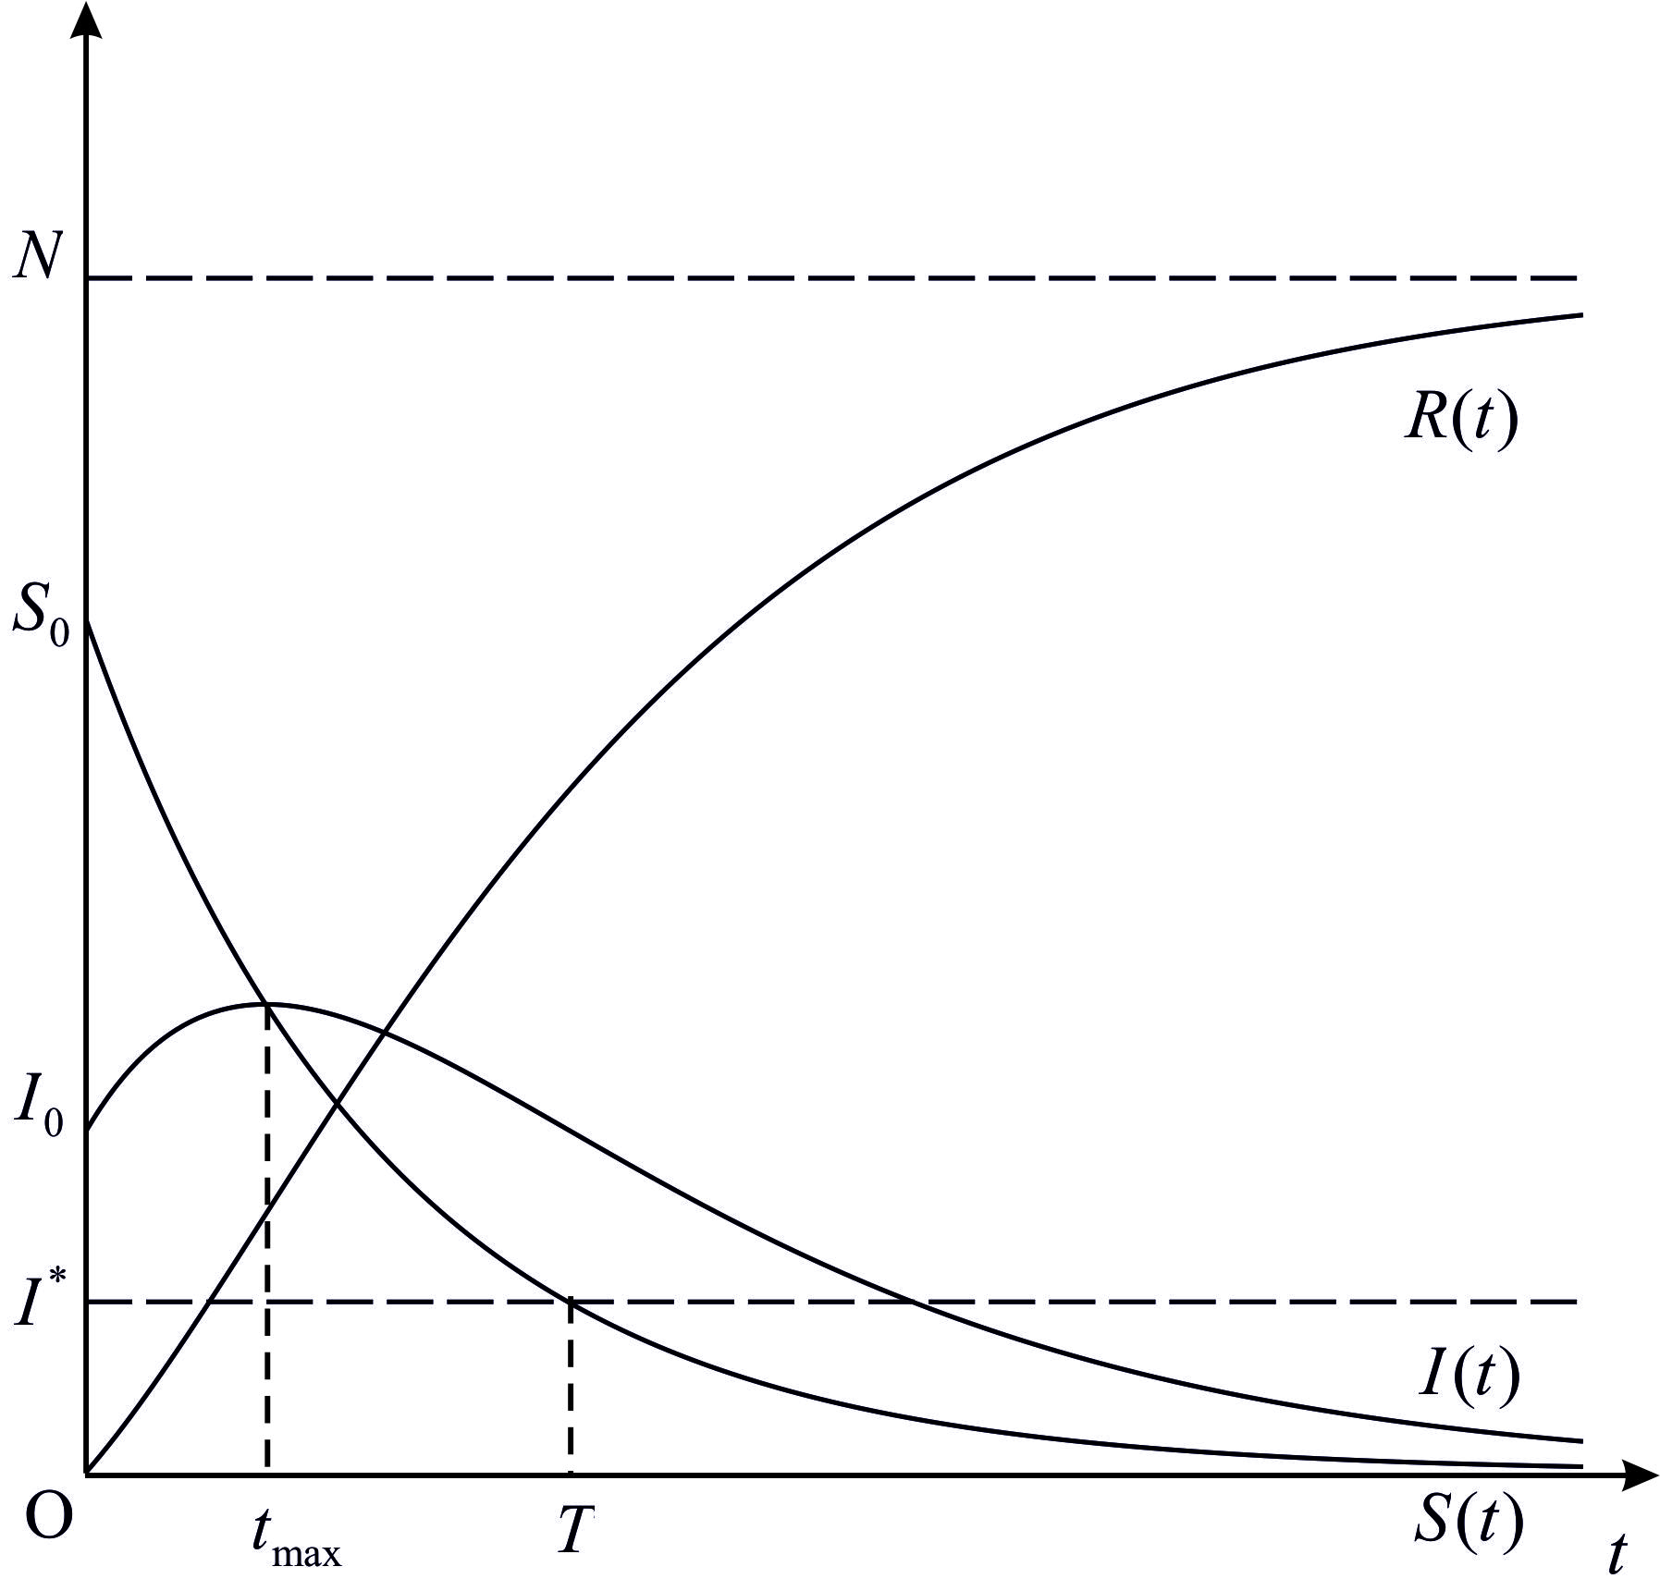
nax. 3.6.4.

naxazze (ix. nax. 3.6.4) grafikulad aris gadmocemuli individTa raodenobis cvlis dinamika TiToeul jgufSi. SevniSnoT, rom funqciis grafiki intervalze qvemoT amozneqilia, misi gadaRunvis wertilia, xolo intervalze is zemoT amozneqilia.
cxadia, rom SeiZleba analogiurad iqnes ganxiluli SemTxvevebi, rodesac
, .
SevniSnoT, rom Cven mier ganxiluli epidemiis gavrcelebis maTematikuri modeli ramdenadme gamartivebulad aRwers realur situacias, radgan igi zogierT mniSvnelovan faqtors ar iTvaliswinebs. Tumca, rogorc eqsperimentul monacemebTan Sedareba gviCvenebs, es gamartivebuli modelic sakmaod karg warmodgenas iZleva infeqciuri daavadebebis gavrcelebis meqanizmze.

*)d. bernuli (1700 _ 1782) _ italieli maTematikosi, meqanikosi, fiziologi, eqimi.
*)i. f. rikati (1676 _ 1754) _ italieli maTematikosi.
**)marTlac, am SemTxvevaSi , saidanac . Tu შემოვიღოთ შემდეგი აღნიშვნა, მაშინ Tu ე.იშემოვიღოთ შემდეგი აღნიშვნა, მაშინ Tu maSin
*)balance – frangulad saswors niSnavs
*) es modeli moyvanilia Semdeg wignSi: W.E. Boyce, R.C. DiPrima, Elementary Differential Equations and Boundary Value Problems, John Wiley & Sons, 2001, ix. gv. 87 N.T.J. Bailey, The Mathematical Theory of Infections Disiases and Applications, New York: Hafner Press, 1975
*)marTlac, .

